

**CCN Lab Mid**

**Submitted by: Fatima Gull**

**Submitted To: Sir Sharjeel**

**Roll no:138-5C**

1. **How many computer laboratories are in the FURC? Name them**

There are **12** Laboratories in **FURC**.

* System Lab 1.
* System Lab 2.
* DLD Lab 1.
* DLD Lab 2.
* SDP-Lab 1.
* SDP-Lab 2.
* Programing Lab 1.
* Programing Lab 2.
* Programing Lab 3.
* Programing Lab 4.
* Programing Lab 5.
* Programing Lab 6.

1. **How many computers are there in each laboratory**
2. to **40** Computers in Each Lab
3. **Describe the configuration of the systems in each laboratory**

* **Topology:**

Star.

* Each Lab Consist of **1 Switch**.
* PC’s are connected to ***LAN***.
* IP’s Address:

**Class C.**

1. **Describe the function of ping, Ipconfig, Netstat, Tracert, Hostname**

**Ping :**

Ping is used to test the reachability of a host on an Internet Protocol network

**ipconfig**:

It provides TCP/IP settings info, IP address, DNS server, DHCP server, default gateway etc.

**Netstat**:

Netstat is a **command-line network utility** that displays network connections for Transmission Control Protocol, routing tables, and a number of network interface and network protocol statistics

**Tracert**:

It is a utility to check connectivity from one computer to another. It gives you the details on each router as it hops from one router to another.

**Hostname:**

 It is used to view a computer's **hostname** and domain name (DNS) (Domain Name Service), and to display or set a computer's **hostname** or domain name

1. **Develop a network for some company with a 5 system in each department.**

**There are three departments also assign ip address to each node and provide detail specification of the network and recommendation? All departments are connected to internet with some web server. How accounts are maintained and also cover detailed aspect of the network. Assign ip address different to different department such that traffic from one node do not travel in other department.**

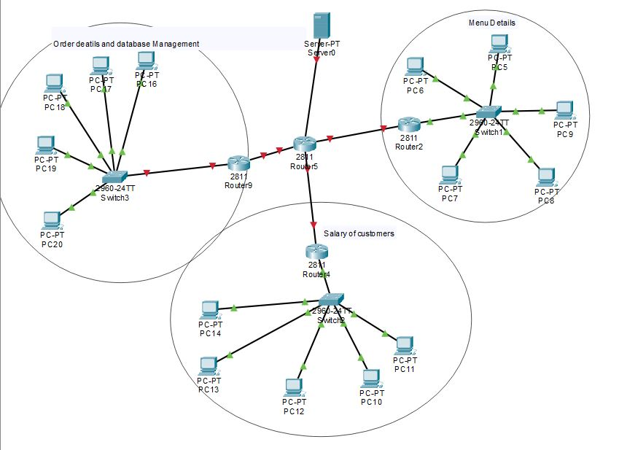

1. **Explain the difference between the classful addressing and the classless addressing?**

**Classless addressing** and **classful** addressing refer to two different ways of IP addresses.  Both terms refer to a perspective on the structure of a subnetted IP address.

**Classless addressing** uses a two-part view of IP addresses, and **classful addressing** has a three-part view.

**Classful** addressing, the address always has an 8-, 16-, or 24-bit network field, based on the Class A, B, and C addressing rules.  The end of the address has a host part that uniquely identifies each host inside a subnet.  The bits in between the network and host part comprise the third part, namely the subnet part of the address**.**

**Classless** addressing, the network and subnet parts from the classful view are combined into a single part, often called the subnet or prefix, with the address ending in the host part.

1. **Change the following IP addresses from dotted-decimal notation to binary notation**
   1. **111.56.45.78**

01101111.00111000.00101101.01001110

* 1. **75.45.34.78**

01001011.00101101.00100010.01001110

1. **Find the class of each address:**
   1. **Roll no**.12.14.87

138.12.14.87

It belongs to Class B

* 1. **Roll no**.5.15.111

138.5.15.111

It belongs to Class B

* 1. **Roll no**.11.78.56

138.11.78.56

It belongs to Class B

1. **Given the address Roll no. Roll no . Roll no . Roll no/14 , find the network address.**

**Roll no 138**

138. 138 . 138 . 138/14

255.255.0.0

10001010. 10001010.138.138/14

11111111. 11111100.0.0

10001010.10001000.0.0

138.136.0.0

1. **Given the address Roll no. Roll no . Roll no . Roll no/14, find the host address.**

138.138.138.138/14

Roll no 138

Host address:0.2.138.138

1. **Given the network address Roll no.0.0.0, find the class.**

138.0.0.0

It belongs to Class B.

1. **Which layer is following devices**

* Programmable switch

**Data link Layer**

* Fire wall routers

**Network layer**

1. **Give tcp packet structure and give one line description of each field**

The TCP packet format consists of following fields

* **Source Port** & **Destination Port** fields (16) bits each identify the end points of Connection
* **Sequence Number field** (32) bits specifies the number assigned to the first byte of data in current message
* **AcknowledgementNumber field** (32) bits contains the value of the next sequence number that the sender of the segment is expecting to receive.
* **Data Offset(a.k.a. Header Length) field** (variable length) tells how many 32-bit words are contained in the TCP header. This information is needed because the Options field has variable length, so the header length is variable too.
* **Reserved field** (6 bits) must be zero. This is for future use.
* **Window field** (16 bits) specifies the size of the sender's receive window (that is, buffer space available for incoming data).
* **Checksum field** (16 bits) indicates whether the header was damaged in transit.
* **Urgent pointer field** (16 bits) points to the first urgent data byte in the packet.
* **Options field** (variable length) specifies various TCP options.
* **Data field** (variable length) contains upper-layer information.

1. **Write down wire configuration of cross cable**

|  |  |
| --- | --- |
| T568A .1 One End | T568A .1 Another End |
| White/Green | White/Orange |
| Green | Orange |
| White/Orange | White/Green |
| Blue | Blue |
| White/Blue | White/Blue |
| Orange | Green |
| White/Brown | White/Brown |
| Brown | Brown |
|  |  |

**15 ) Find the class of each address:**

* 1. **227**.12.14.87/17

**It belongs to Class D**

* 1. **252**.5.15.111/18

**It belongs to Class E**

* 1. **134**.11.78.56/15

**It belongs to Class B**